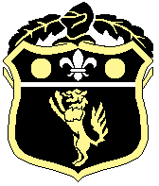
Old Wilsonians Cricket Club

Useful Safeguarding Contacts

OWCC Safeguarding Officer
Margo Lawrence margoowcolts@aol.com 07850 446 874

Kent County Safeguarding Officer
Bridget Owen kcbcwo.kent@ecb.co.uk 01227 473 618

ECB Safeguarding Team
safeguarding@ecb.co.uk 020 7432 1200

Bromley Local Authority Designated Officer (LADO)
020 8461 7775 020 8313 4325
Out of Hours Emergency Team 0300 303 867
For information www.bromleysafeguarding.org

Bromley Multi-Agency Safeguarding Hub (MASH)
mash@bromley.gov.uk

The Samaritans
jo@samaritans.org or call 116 123

NSPCC
www.nspcc.org.uk/about-us/contact-us/ or call 0808 800 5000

